Visit Report: Pathorghata Upazila Health Complex, Barguna
Date of Visit: 24/08/22; Time: 12:45 PM.
Visitor: Dr. Md. Emdadul Haque, National Consultant (HEU) &
Dr. Nazmur Rahman Sajib, Junior National Consultant (HEU)

1. We arrived at 12:45 pm in the health complex. UH&FPO and all the medical officers were present in the health complex. We met with them, discuss about the overall situation of the health complex
2. The infra-structure of this Upazila Health Complex is 50 bedded. The population of the Upazilla is 1,92,663 having 7 unions, one Union Sub-centre- five H&FWC and 21 Community Clinic. The physical condition of the hospital building is good. The dranage system of the health complex is blocked.So devloped a water-loaging area3.All the post of Consultants are vacant and consultant anesthesia-resigned from the post. So caesarean section is not being performed. The post of Dental surgeon & MT(Dental) is vacant. So dental service is not possible.
4.There is no cycle stand . There are many motorcycles parked in the premises.

5.The outdoor was crowded with patients. We also observed emergency, pathology and pharmacy department. The information display system was weak.
6. There was no effective health education system.
7.Ultra-sonographic, ECG, service is functioning but X-Ray service is not functioning. A packet of X-Ray machine is not opened and installed for long five years.
8. The spaces of emergency is congested. But SSK Booth and Pharmacy can be established close to the emergency department.

9. Cleanliness of the hospital premises, outdoor and indoor was satisfactory, but wash room was not clean.
10.There is a separate OT having no equipment.
11.The roof of the health complex is not clean. There are many bushes on the roof.
12.There are many “Danbox” throughout the UHC, and advised for removing those immediately.
13.There is a small conference room in the UHC close to the office of the UH&FPO.
14.In 2021, total OPD patient was 24,620,in emergency 6152 and in indoor admitted patient was 5878. Bed occupancy rate was 85.5%. Total ANC 1st visit in 2021 was 129 and total delivery was 52.

Human Resources: 50 Bedded Hospital:
Sl. | Designation | No. of Post | Present | Vacant
1. | UH&FPO | 01 | 01 | 0
2 | RMO | 01 | 01 | 0
3. | Junior Consultant | 11 | 01(Anesth,resign) | 10
4. | Medical Officer | o3 | 03 | 0
5. | MO(Dental) | 01 | 0 | 01
6. | Medical Officer (OSD) | 10 | 10 | 0
7. | Nurses | 32 | 32 | 0
8. | Mid wives | 05 | 05 | 0
9. | Medical Technologist (Lab) | 03 | 01mT | 03
10. | MT EPI | 01 | 01 | 0
11. | MT(Dental) | 01 | 0 | 01
12 | MT (Radiology) | 01 | 0 | 01
13. | SACMO (UHC + Field) | 09 | 01 | 08
14. | Pharmacist | 03 | 0 | 03
15. | Health Inspector (HI) | 03 | 01 | 02
16. | Sanitary Inspector | 01 | 01 | 0
17. | Assist. Health Inspector | 08 | 04 | 04
18. | Health Assistant | 40 | 33 | 07
19. | CHCP | 21 | 20 | 01
20. | Head Assistant | 01 | 01 | 0
21. | Cashier | 01 | 01 | 0
22. | Accountant | 01 | 0 | 0
23. | Statistician | 01 | 0 | 0
24. | OA/Comp. operator | 03 | 0 | 03
25. | Store Keeper | 01 | 0 | 01
26. | Cardiographer | 01 | 01 | 0
28. | MLSS+ Ward boy | 08 | 04 | 04
29. | Cleaner | 05 | 01 | 04
30. | Guard | 02 | 02 | 0
31. | Gardener | 01 | 01(Depu. Barguna) | 0
32. | Cook | 02 | 01 | 01
33. | Attendent (Lab,Emergen,OT) | 03 | 03 | 01
34. | Driver (Ambulance) | 01 | 01 | 0
35. | Outsourcing: Driver | 01 | 01 | 0
36. | FWA | 39 | 27 | 12

Status in HSS Score From Jan-July.
Name | Janu | Feb | Mar | April | May | June | July
Barguna D-Hospi | 03 | 07 | 19 | 22 | 21 | 16 | 19
Amtoli UHC | 319 | 200 | 255 | 298 | 207 | 368 | 353
BetagiUHC | 306 | 314 | 304 | 332 | 340 | 337 | 341
BamnaUHC | 221 | 162 | 290 | 230 | 279 | 277 | 279
PathorghataUHC | 209 | 291 | 347 | 258 | 248 | 270 | 385
Taltoli UHC | - | - | - | - | - | - | -

Status of Building Blocks of C-J Model in the Pathorghata UHC:
Sl | Criteria of C-J Model | Best | Good | Weak
01 | Cycle stand close to the main gate |  |  | √
02 | Health Education |  | √
03 | Cleanliness & beautification |  |  | √
04 | Separation of patients in out door & indoor |  |  | √
05 | Blood doner list with 24/7 B.T facility |  | √
06 | Birth- death recording |  |  | √
07 | Reception Desk |  |  | √
08 | Developed Emergency Dept. |  | √
09 | 5S –KAIZEN implementation. |  |  | √
10 | Community Participation. |  | √
11 | Hospital activities Display |  |  | √
12 | Corner based service. |  | √
13 | Cash counter for receiving Govt money. |  |  | √
14 | Devolped maternal health/labour word. |  |  | √
15 | Devolped paediatric health |  |  | √
16 | Position in HSS score in July22.  (Best= <100; Good= 101-200; Weak= >200) |  |  | √
17 | Power point Presentation &Video on UHC |  |  | √
18 | Knowledge about 8th Five Year plan & SDG. |  |  | √
19 | Zero-Tollarance on corruption |  | √

Recommendations:
1. The dranage system of the health complex should be improved The local powroshova must take part in solving the problame.
2. All the post of consultants specially gynae and anesthesia should be filled up immediately for the development of improved maternal health.
2. Cleanliness and beautification is satisfactory. The local Powroshova must take part in waste management.
3. There should be funtioning OT room for major operation in the health complex.
5. Condemetion Board should work to destory all unwanted items.
6. All the vacant posts of 4th class should be fulfilled immediately.
7. The post of Dental Surgeon and Medical Technologist (Dental), Medical Technology (Radiology)must be fulfilled to start dental& radiology services.
8. Replication of C-J model will help in development of the quality of care and it should be followed properly.
14. There should be a Complaints and Suggestion box in front of UH&FPO room
15. The roof of the health complex building should be cleaned.
16. There should be availability of safe drinking water.
17. All the “Danbox” of the UHC, should be remove.
18.The performance of all services must be improved, because of underutilization of the health complex.

Photos of UHC, Pathorghata taken from the visit are shown below:
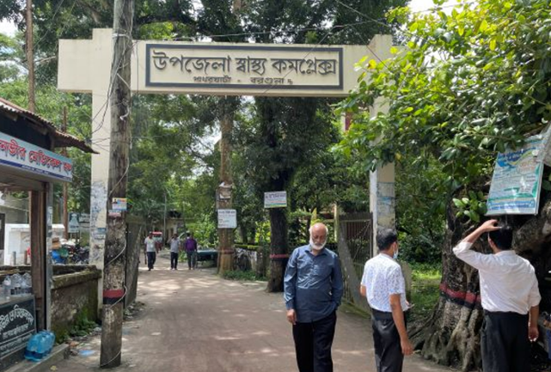
Fig 1: UHC gate; unwanted poster should be removed;
There is no guiding sign for UHC
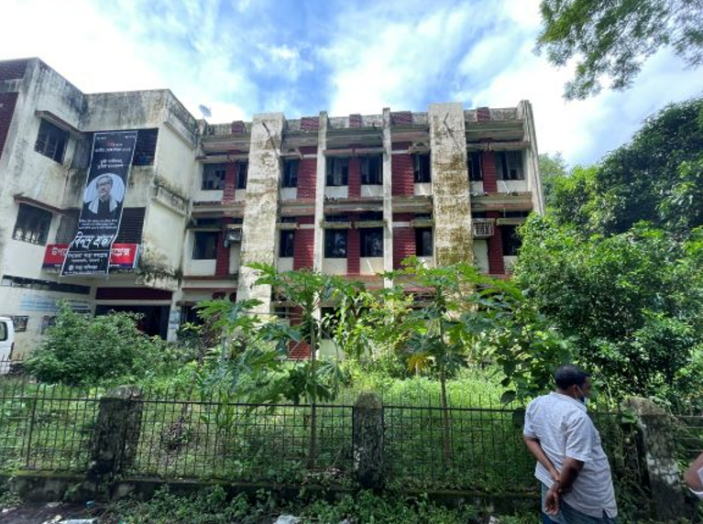
Fig 2: Unclean garden
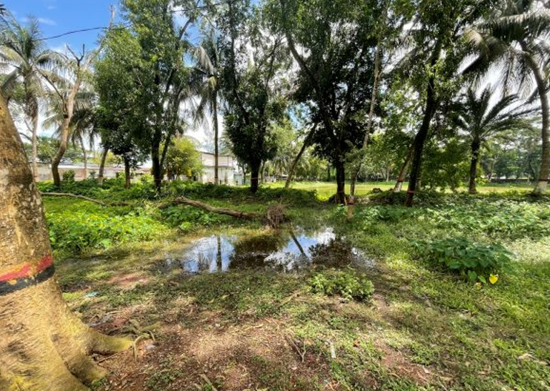
Fig 3: Unclean Campus

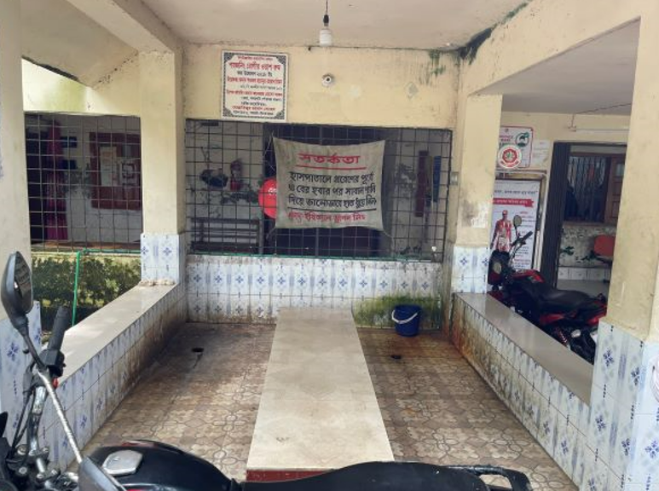
Fig 4: Privacy not maintained in poison washing center
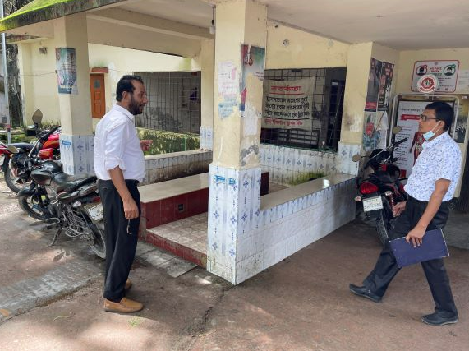
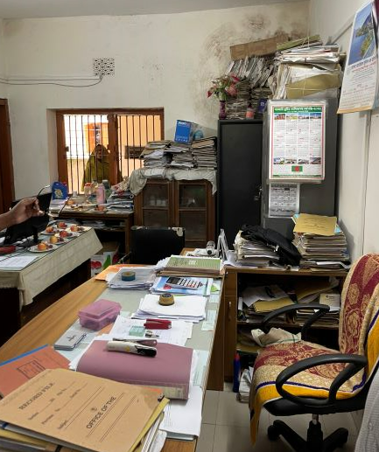
Fig 5: Motorcycles scattered in hospital premises as there is no cycle stand
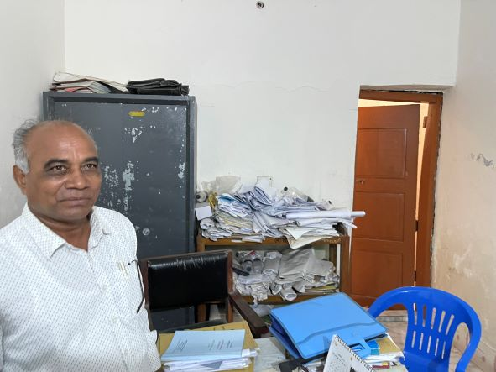

Fig 6: Disorganized file management in office
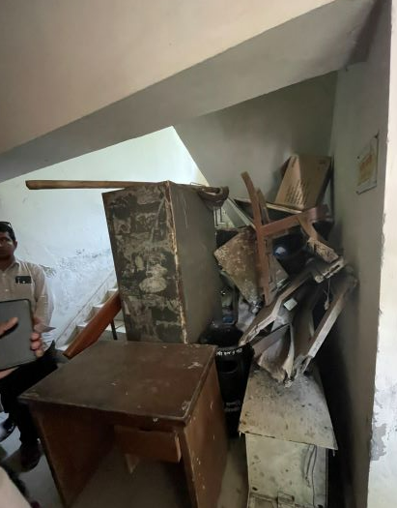
Fig 7: Unwanted items in the corridor

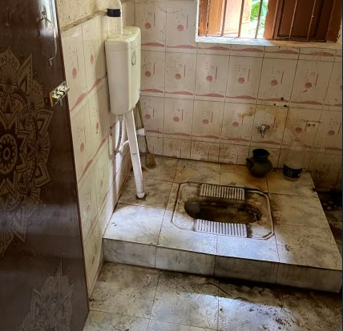
Fig 8: Unclean toilets in the hospital

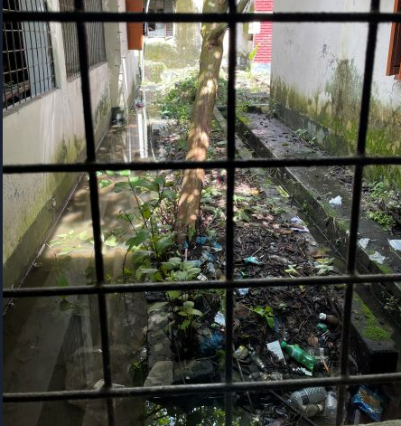
Fig 9: Side of hospital building is filled with dirty materials

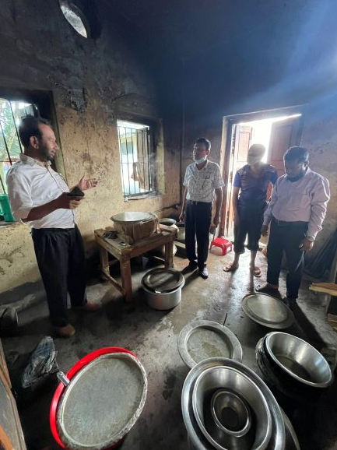
Fig 10: Unclean kitchen with non-functioning exhaust fan
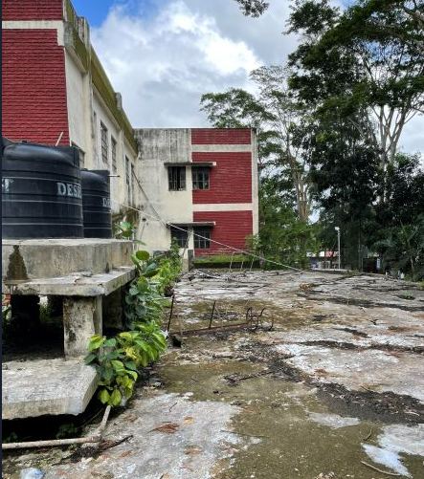
Fig 11: Unclean roof of the hospital building

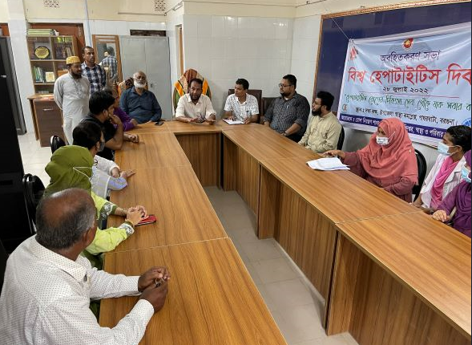
Fig 12: Small conference room attached with UHFPO office

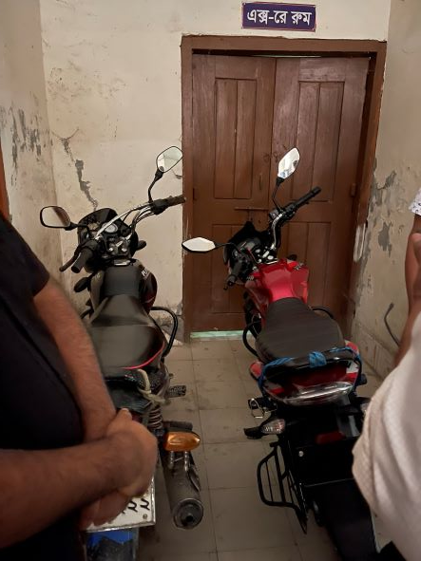

Fig 13: Motorcycle parked in the hospital corridor

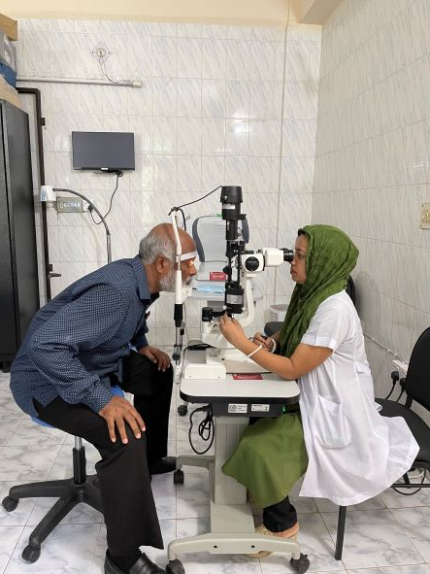

Fig 14: Functioning Vision Centre (Good Practice)

